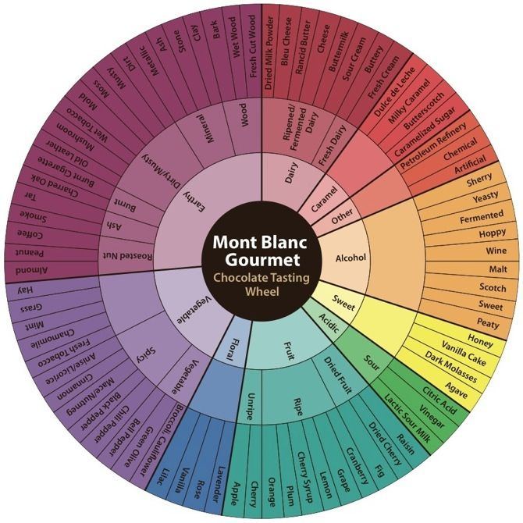
CHOCOLATE DIFFERENTIATION

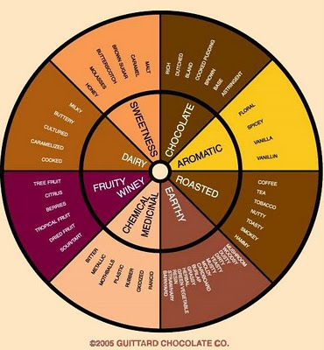

Flavor notes

If you experience: | It may be a result of:
Acidity (low) | •Proper length of conching, which varies, allows acidity to evaporate
Acidity (high) | •Short fermentation  • Cocoa grown in highly acidic soils. Soils with low phosphorous levels and higher amounts of iron and copper salts  • Drying too fast stops the chemical reactions started in fermentation and  prevents the escape of part of the remaining acids and tannins in the bean, resulting in acidic and astringent flavors. Artificially dried beans may also  be more acidic as the drying time is shortened
Astringency | • Germinated beans can cause this  • Drying too fast - as above
Bitterness | Short fermentation. This may be due to a result of lack of knowledge or  some mass market companies do this purposely to save time & money  • Fermenting different types of beans together can cause over-fermenting  of one type and under-fermenting of another
Blandness | • Too much conching can decrease some flavors  • Too much cocoa butter  • Possibly the result of deodorizing cocoa butter. This involves passing steam through the butter, which is under a vacuum. While removing off-flavors it can also remove desirable flavors
Burnt rubber | • Use of unfermented beans  • Artificial drying methods
Caramel flavor | • Considered desirable, it is brought out by proper roasting,  which varies by bean type
Cardboard flavor | • May be transferred from packaging
Creaminess | • Use of an emulsifier such as lecithin  • Added cocoa butter  • Long conching period
Earthy notes | • Considered desirable, enhanced by proper roasting, which varies  by bean type
Floral notes | • Considered desirable, enhanced by proper roasting, which varies  by bean type
Fruity flavors | • Varies by bean type - a number of different fruit flavors may be detected
Grainy texture | • Conching was not adequate  • Chocolate not tempered properly
Grassy odors | • Beans stored under humid conditions may absorb the odor of the bag they are kept in
Ham | • Smoke from drying the beans over wood fires (regions that harvest a lot  of cocoa during rainy seasons or cloudy weather often use artificial  drying methods to decrease moisture)  • Over fermentation

Appearance notes

- Dark chocolate: deep, intense mahogany hues
- Milk chocolate: auburn, dark violets and rustic reds
- White chocolate: yellow, butters and creams
- Is it glossy or dull?
- Is there a white film across the surface?
- Good chocolate should be smooth and dry on your fingertips and it should not feel sticky, gritty or waxy. Gently run your finger across the back of the bar and see how yours performs.
  - Now gently rub the corner. It should start to melt slightly from the warmth of your fingers when you rub a little. Chocolate starts to melt at below body temperature so you should see some residue left on your fingertips at this point.
- You should hear a snap. That is the cocoa butter crystals, which were formed during the tempering process, snapping. If the bar has been tempered correctly, the snap should be ring clearly and not be a dull thud.

