**CHOCOLATE DIFFERENTIATION**

|  |  |  |  |  |  |  |  |
| --- | --- | --- | --- | --- | --- | --- | --- |
| **Type of Chocolate**  **(milk, dark, white, other)** | **Cocoa %** | **Color** (refer to color chart on wall if needed) | **Aroma**  (fruity, spicy, earthy, etc.) | **Mouthfeel** (melt, texture) | **Flavor(s)** | **Aftertaste/ After feel** | **Other notes** |
|  |  |  |  |  |  |  |  |
|  |  |  |  |  |  |  |  |
|  |  |  |  |  |  |  |  |
|  |  |  |  |  |  |  |  |
|  |  |  |  |  |  |  |  |
|  |  |  |  |  |  |  |  |
|  |  |  |  |  |  |  |  |
|  |  |  |  |  |  |  |  |
|  |  |  |  |  |  |  |  |
|  |  |  |  |  |  |  |  |
|  |  |  |  |  |  |  |  |
|  |  |  |  |  |  |  |  |
|  |  |  |  |  |  |  |  |
|  |  |  |  |  |  |  |  |
|  |  |  |  |  |  |  |  |
|  |  |  |  |  |  |  |  |
|  |  |  |  |  |  |  |  |
|  |  |  |  |  |  |  |  |
|  |  |  |  |  |  |  |  |
|  |  |  |  |  |  |  |  |
|  |  |  |  |  |  |  |  |
|  |  |  |  |  |  |  |  |
|  |  |  |  |  |  |  |  |
|  |  |  |  |  |  |  |  |
|  |  |  |  |  |  |  |  |

**Flavor Notes**

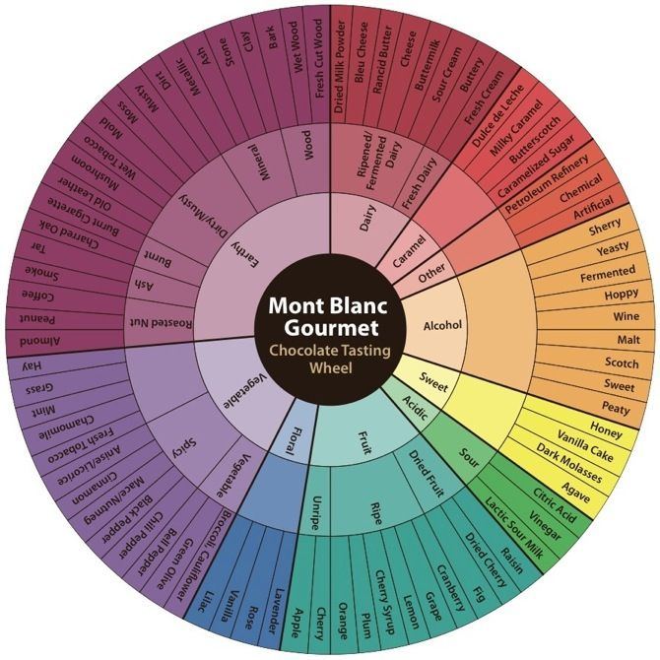

|  |  |
| --- | --- |
| If you experience: | It may be a result of: |
| Acidity (low) | *•Proper length of conching, which varies, allows acidity to evaporate* |
| Acidity (high) | *•Short fermentation*  *• Cocoa grown in highly acidic soils. Soils with low phosphorous levels and higher amounts of iron and copper salts*  *• Drying too fast stops the chemical reactions started in fermentation and*  *prevents the escape of part of the remaining acids and tannins in the bean, resulting in acidic and astringent flavors. Artificially dried beans may also*  *be more acidic as the drying time is shortened* |
| Astringency | *• Germinated beans can cause this*  *• Drying too fast - as above* |
| Bitterness | *Short fermentation. This may be due to a result of lack of knowledge or*  *some mass market companies do this purposely to save time & money*  *• Fermenting different types of beans together can cause over-fermenting*  *of one type and under-fermenting of another* |
| Blandness | *• Too much conching can decrease some flavors*  *• Too much cocoa butter*  *• Possibly the result of deodorizing cocoa butter. This involves passing steam through the butter, which is under a vacuum. While removing off-flavors it can also remove desirable flavors* |
| Burnt rubber | *• Use of unfermented beans*  *• Artificial drying methods* |
| Caramel flavor | *• Considered desirable, it is brought out by proper roasting,*  *which varies by bean type* |
| Cardboard flavor | *• May be transferred from packaging* |
| Creaminess | *• Use of an emulsifier such as lecithin*  *• Added cocoa butter*  *• Long conching period* |
| Earthy notes | *• Considered desirable, enhanced by proper roasting, which varies*  *by bean type* |
| Floral notes | *• Considered desirable, enhanced by proper roasting, which varies*  *by bean type* |
| Fruity flavors | *• Varies by bean type - a number of different fruit flavors may be detected* |
| Grainy texture | *• Conching was not adequate*  *• Chocolate not tempered properly* |
| Grassy odors | *• Beans stored under humid conditions may absorb the odor of the bag they are kept in* |
| Ham | *• Smoke from drying the beans over wood fires (regions that harvest a lot*  *of cocoa during rainy seasons or cloudy weather often use artificial*  *drying methods to decrease moisture)*  *• Over fermentation* |

**Appearance notes**

* Dark chocolate: deep, intense mahogany hues  
  Milk chocolate: auburn, dark violets and rustic reds  
  White chocolate: yellow, butters and creams  
  Is it glossy or dull?
* Is there a white film across the surface?
* Good chocolate should be smooth and dry on your fingertips and it should not feel sticky, gritty or waxy. Gently run your finger across the back of the bar and see how yours performs.  
  Now gently rub the corner. It should start to melt slightly from the warmth of your fingers when you rub a little. Chocolate starts to melt at below body temperature so you should see some residue left on your fingertips at this point.
* You should hear a snap. That is the cocoa butter crystals, which were formed during the tempering process, snapping. If the bar has been tempered correctly, the snap should be ring clearly and not be a dull thud.
* 